**Get Lit, Get Fit**

**Software Requirements Specification**

**CEN 3031, FALL, 2018**

**Modification history:**

|  |  |  |  |
| --- | --- | --- | --- |
| Version | Date | Who | Comment |
| v1.0 | 10/15/18 | Group | Mapped out what the application will have. Three different screens were also created to start the design process. We added more shall statements to further define our program. |
| v1.1 | 12/4/18 | Group | Finished final touches on the deliverable, added a database and white box tested the program. Some minor design issues were also fixed to maximize functionality for the user. |

**Team Name:** Syntacky

**Team Members:**

* Hannah Andrews: [handrews0101@eagle.fgcu.edu](mailto:handrews0101@eagle.fgcu.edu)
* Cody Buckley: [cbuckley6232@eagle.fgcu.edu](mailto:cbuckley6232@eagle.fgcu.edu)
* Freddy Curiel: [fcuriel4360@eagle.fgcu.edu](mailto:fcuriel4360@eagle.fgcu.edu)
* Zechariah Dominguez: [zrdominguez1017@eagle.fgcu.edu](mailto:zrdominguez1017@eagle.fgcu.edu)
* Reiner Escalona: [rescalona4605@eagle.fgcu.edu](mailto:rescalona4605@eagle.fgcu.edu)

**Contents of this Document**

[Introduction](https://docs.google.com/document/d/11MdkALp-BZXioRgoRs_Din97LGJbhNpfKYoaNwnOWTo/edit#bookmark=id.30j0zll)

* [Software to be Produced](https://docs.google.com/document/d/11MdkALp-BZXioRgoRs_Din97LGJbhNpfKYoaNwnOWTo/edit#bookmark=id.1fob9te)
* [Definition, Acronyms, and Abbreviations](https://docs.google.com/document/d/11MdkALp-BZXioRgoRs_Din97LGJbhNpfKYoaNwnOWTo/edit#bookmark=id.3znysh7)

[Product Overview](https://docs.google.com/document/d/11MdkALp-BZXioRgoRs_Din97LGJbhNpfKYoaNwnOWTo/edit#bookmark=id.2et92p0)

* [Assumptions](https://docs.google.com/document/d/11MdkALp-BZXioRgoRs_Din97LGJbhNpfKYoaNwnOWTo/edit#bookmark=id.tyjcwt)
* [Use Case Diagram](https://docs.google.com/document/d/11MdkALp-BZXioRgoRs_Din97LGJbhNpfKYoaNwnOWTo/edit#bookmark=id.3dy6vkm)
* [Use Case Descriptions](https://docs.google.com/document/d/11MdkALp-BZXioRgoRs_Din97LGJbhNpfKYoaNwnOWTo/edit#bookmark=id.1t3h5sf)

[Specific Requirements](https://docs.google.com/document/d/11MdkALp-BZXioRgoRs_Din97LGJbhNpfKYoaNwnOWTo/edit#bookmark=id.4d34og8)

**SECTION 1: Introduction**

Software to be Produced:

* This software program is a desktop application that will aid in one’s fitness journey. The application will allow the user to track their nutritional information. The system will also allow the user to track their workouts and have a number of workouts to follow according to their goals (ie. lose weight, gain weight, gain muscle, ect.). Each plan will be customized by the users sex, weight, and height. The system takes multiple factors into account when aiding in the users weight-loss journey including things such as water intake, and different foods. The user will receive either daily or weekly motivational quotes and also a weekly summary of their progress to show how they are progressing in the program. The user will also be able to access daily videos which will allow them to gain more knowledge about things such as proper form, healthy eating, and different exercises they can try.

Definitions, Acronyms, and Abbreviations:

* None

**SECTION 2: Product Overview**

Assumptions:

* System will have Windows10 or MacOS
* The system will have at least 2GB of RAM
* The system will have at least an i3 processor
* Able to run on GOTS products (should government sectors choose to use the program)
* Able to run on COTS products
* The system has integrated graphics
* The system is for home use
* User will have availability to the internet

Use Case Diagram:

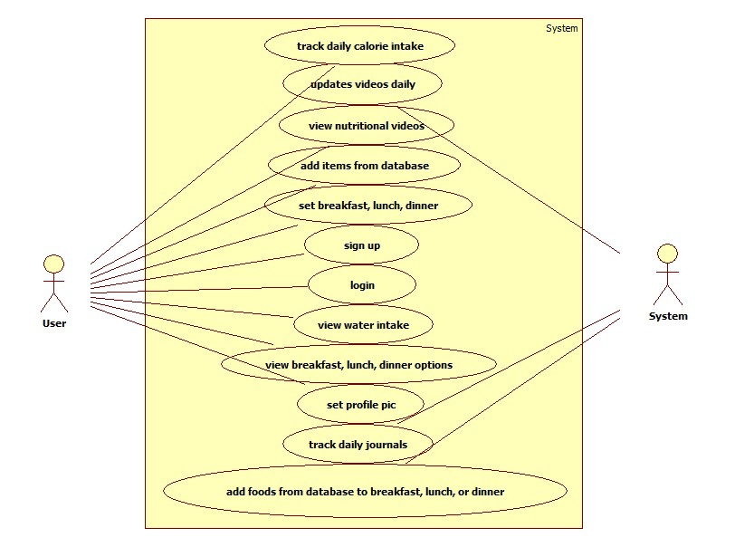

Use Case Descriptions

* **Track daily calorie intake** – All users have the option to use their calorie intake as their dietary plan. The system shall keep track of their calories and progress in their dietary plan and display it.
* **Updates Videos Daily** – Users will have the ability to access videos in order to help them in their fitness journey. These videos will be linked to a button that can be accessed from within their account.
* **View Nutritional Videos** - User will be able to utilize embedded videos that will be updated every day to aid them in things such as meal prep and knowing the correct serving size.
* **Add Items from the Database** – User will be able to customize the things they eat by inputting data from the food that may not already be in the database. This will add it to the database for future reference.
* **Set breakfast, lunch, dinner** – User will be able to choose things from the list or input custom foods as mentioned in the previous description to add to their food journal. This will allow the system to then track the calories and based on what the users recommended caloric intake is, tell the user how many calories they have left for the day.
* **Sign up/log in** – All users will be provided the ability to sign up if they do not have a prior account. The system will save this sign in information in an array list in order to allow the user to have a profile for the program.
* **View water intake** – Premium users have a select option to keep track of their daily water intake. This will provide a counter to keep track for the users to view and record how much water they were drinking compared to other fluids in their diet.
* **View food/select food items** – All users will have the option to view food from the system’s database. They will be able to select the foods based on their nutritional information and add them to build scheduled meals.
* **Create goals; view progress** – These are clumped together for all users. Users will be able to choose from a list of current goals provided by the system. Then, they will be able to follow their progress with the selected goals.
* **View food/select food items** – All users will have the option to view food from the system’s database. They will be able to select the foods based on their nutritional information and add them to build scheduled meals.
* **Profile Customization**  - All users will have the ability to customize their profile to determine their nutritional needs based on their weight loss/gain goals. The user will also have the ability to add a custom profile picture

**SECTION 3: Specific Requirements**

|  |
| --- |
| **No. 1** |
| **Statement:** The system shall calculate the user's daily calorie intake based on sex, weight and height inputted by the user at their signup. |
| **No. 2** |
| **Statement:** The system shall generate the number of carbs, fat and protein that the user should consume daily based on the information the user provides at their signup. |
| **No. 3** |
| **Statement:** The system shall allow the user to input a custom profile picture in the profile section of their account. |
| **No. 4** |
| **Statement:** The system shall allow users to upload their own foods that are not already into the database into the database for future reference. |
| **No. 5** |
| **Statement:** The system shall allow the user to create weekly weight goals, this includes weight loss and weight gain. |
| **No. 6** |
| **Statement:** The system shall provide and daily videos for the user, to motivate them with their diet plan. |
| **No. 7** |
| **Statement:** The system shall allow the user to receive daily or weekly motivational quotes upon request. |
| **No. 8** |
| **Statement:** The system shall provide a calorie counter in order to show progress in the diet plan. |
| **No. 9** |
| **Statement:** The system shall track user login information which includes their username and password that they made to sign in. The user will be able to have their choice with logging in and there will be no username or password restrictions. |
| **No. 10** |
| **Statement:** The system shall provide a database with a variety of foods which will include a variety of vegetables, fruits and meat. The system shall also allow user input into the database for food items that may not already be there. |
| **No. 11** |
| **Statement:** The system shall provide nutritional facts for foods stored within the database, as well as allowing the user to enter custom foods and their nutritional information. |
| **No. 12** |
| **Statement:** The system shall save the custom input food that the database does not already have. |
| **No. 13** |
| **Statement:** The system shall allow the user to know when their caloric intake for the day has been met based on the food they add and the caloric calculator on the main page of the users account. |
| **No. 14** |
| **Statement:** The system shall have a water intake counter which will allow the user to see the amount of water they are taking in everyday and whether their goal is met or not. |
| **No. 15** |
| **Statement:** The system shall allow the user to add a profile picture to show progress through the time that their account is active. |
| **No. 16** |
| **Statement:** The system shall provide a network different daily quotes to use for motivation that will be randomly generated daily. |
| **No. 17** |
| **Statement:** The system shall provide a series of videos to help with different aspects of motivation, the source of the videos is YouTube and located on the main page. |
| **No. 18** |
| **Statement:** The system shall record the number of carbs, fat, and protein that the user should consume daily. |
| **No. 19** |
| **Statement:** The system shall provide a daily progress report to show the users how they are progressing through different aspects of their fitness journey such as caloric intake and water. |
| **No. 20** |
| **Statement:** The system shall be able to track foods added to breakfast, lunch, and dinner parts of the program. This will be entered by the user and will be displayed on the food diary. |

Template created by G. Walton ([GWalton@mail.ucf.edu](mailto:GWalton@mail.ucf.edu)) on Aug 30, 1999 and last updated Aug 15, 2000; updated by A. Koufakou, Aug 2014

This page last modified by Hannah Andrews ( [handrews0101@eagle.fgcu.edu](http://%20handrews0101@eagle.fgcu.edu) ) on 12/04/2018